* 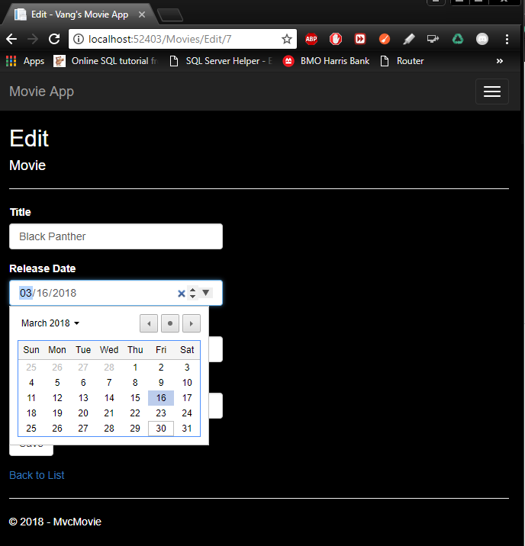**5 points - Paste your results below showing editing the Release Date and Price, including the heading change made for the Release Date:**

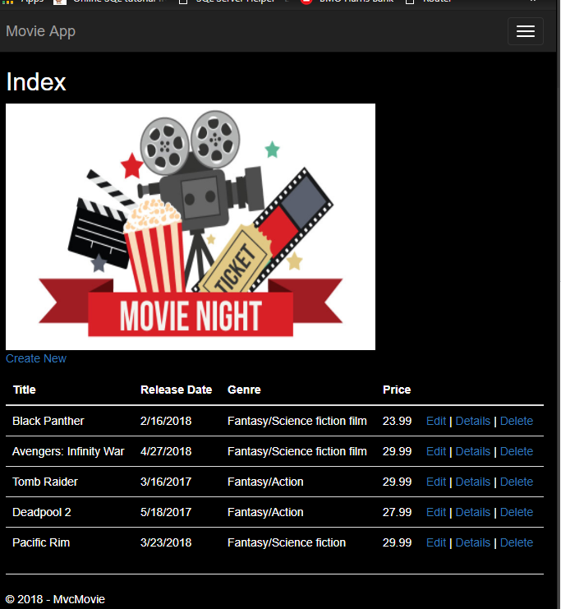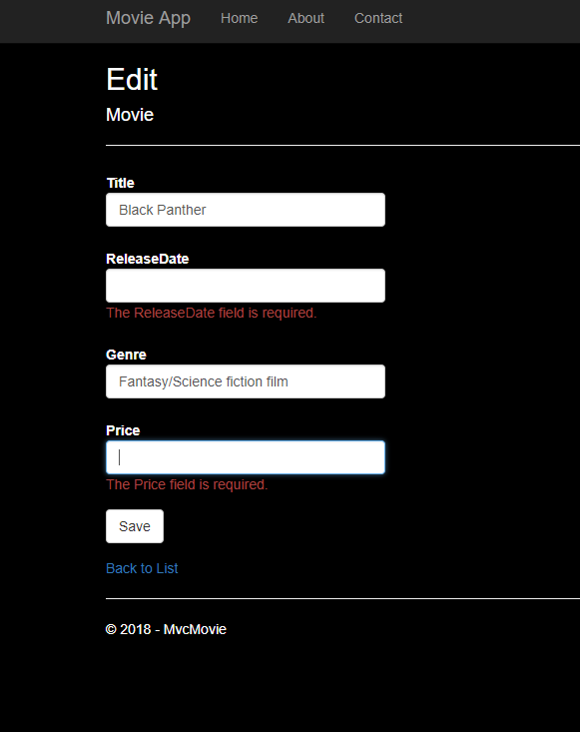

* + 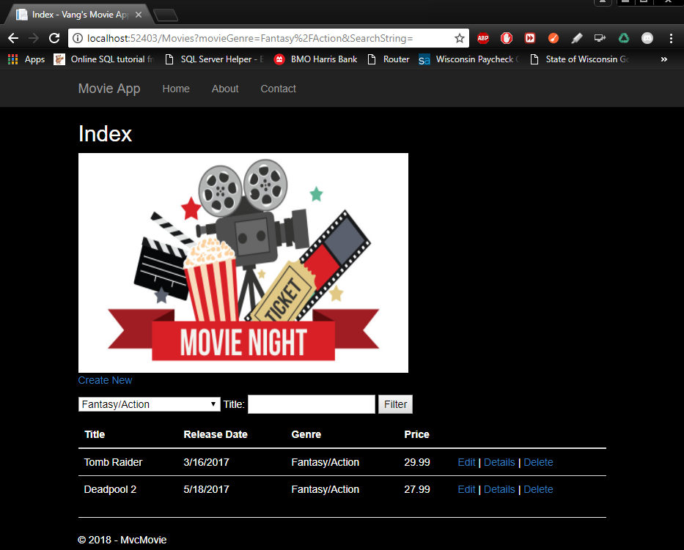**5 points – Copy/Paste your results below – searching by Genre – “Western”, Title = blank, ensuring both of your search strings show in the URL:**
  + 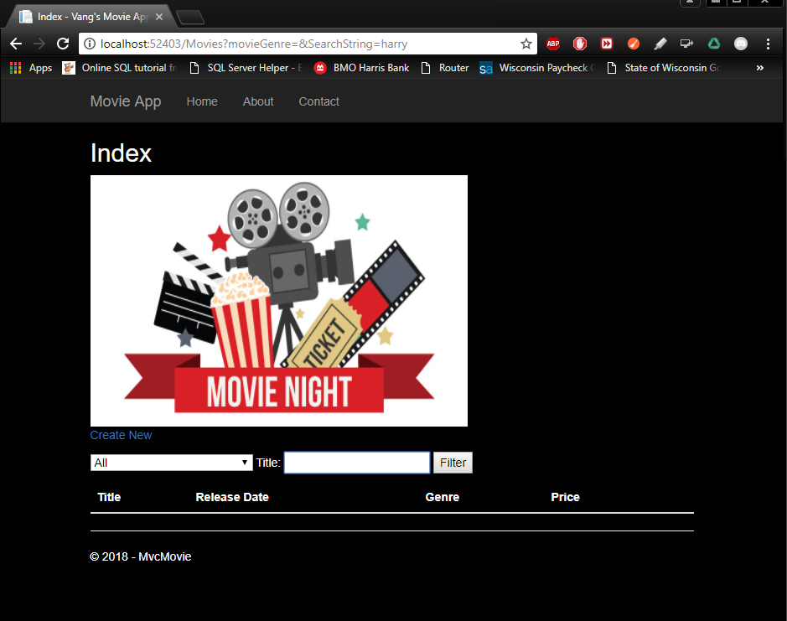**5 points – Copy/Paste your results below – searching by genre – “All”, Title = “harry”, ensuring both of your search strings show in the URL:**
  + 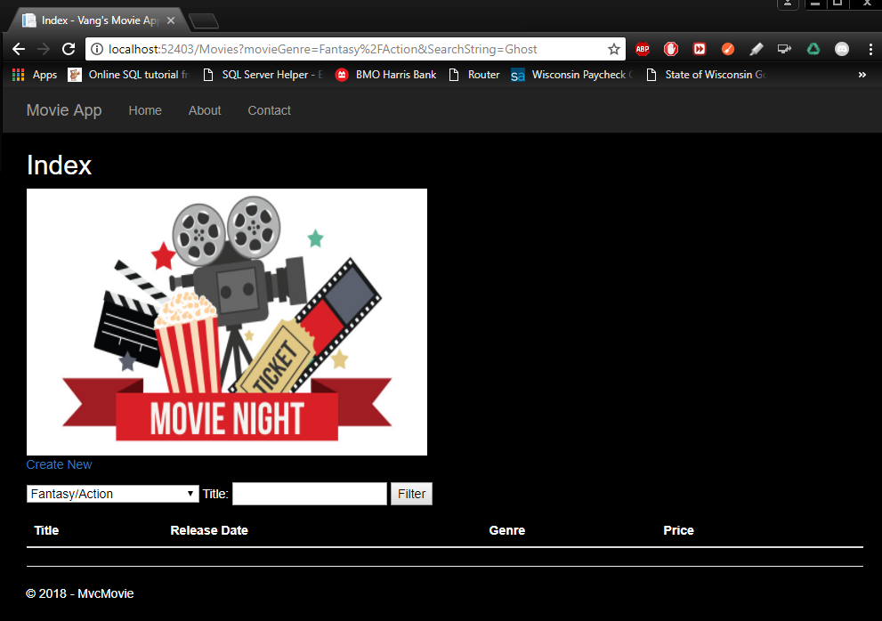**5 points – Copy/Paste your results below the sample shown below – searching by Genre = Comedy and Name = “ghost”, ensuring both of your search strings show in the URL**
* **5 points – Test your project.** 
  + 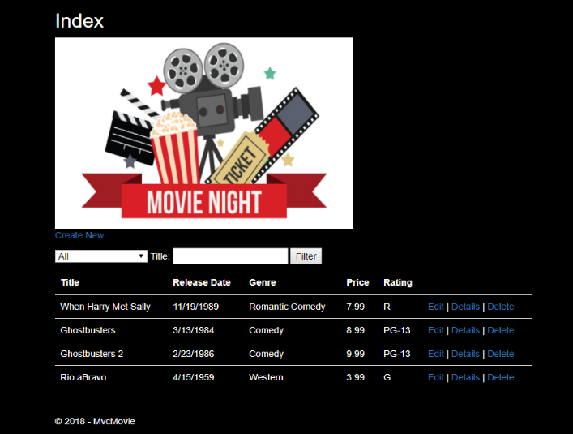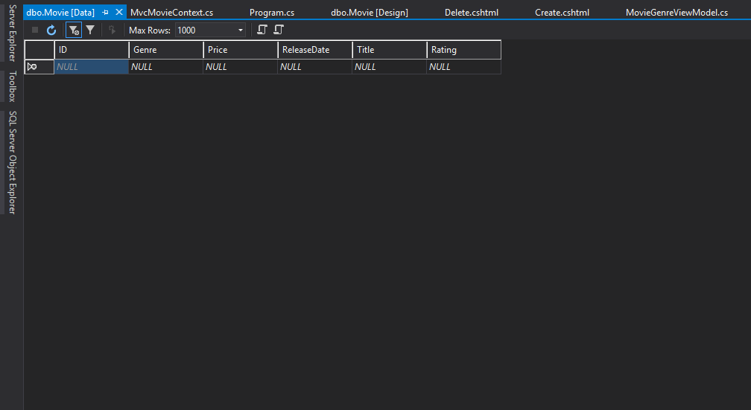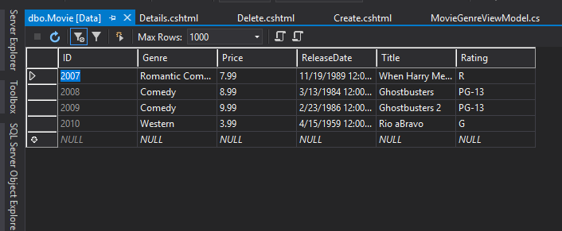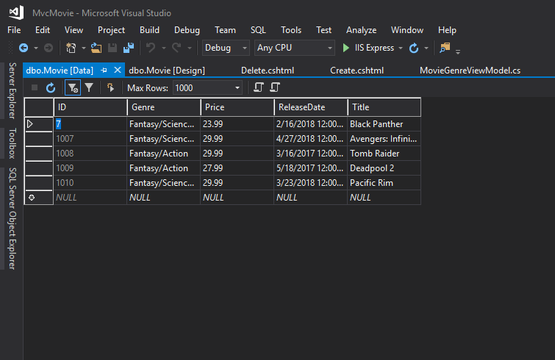**Paste results of your database with the new rating property. This should include all records from the SeedData method again:**
* **5 points - Test out your Create methods to see if your Rating field works correctly. Add a movie of your choice.** 
  + 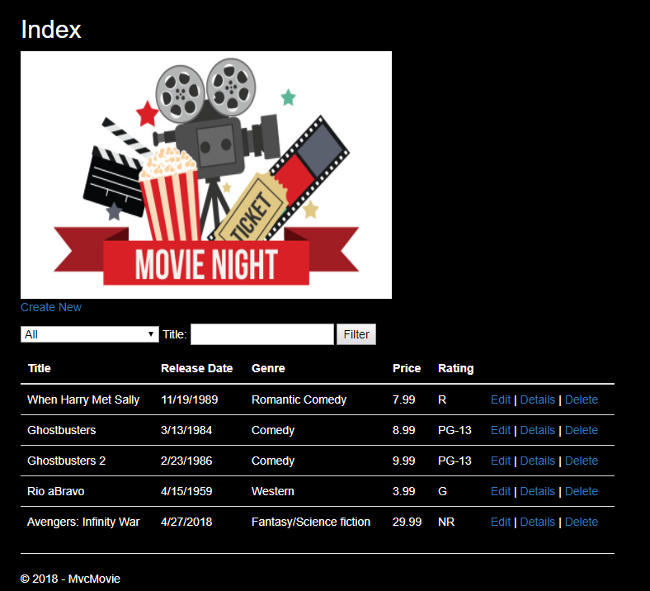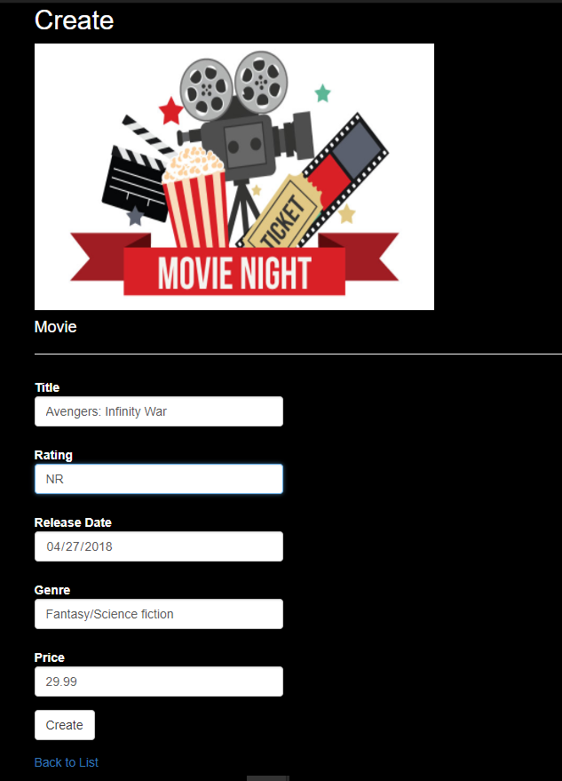**Paste results of adding a new movie - circle your new movie:**
* **5 points - Test out your Edit method to see if the new Rating field may be updated. Change both Ghostbuster movie ratings to G.**
  + 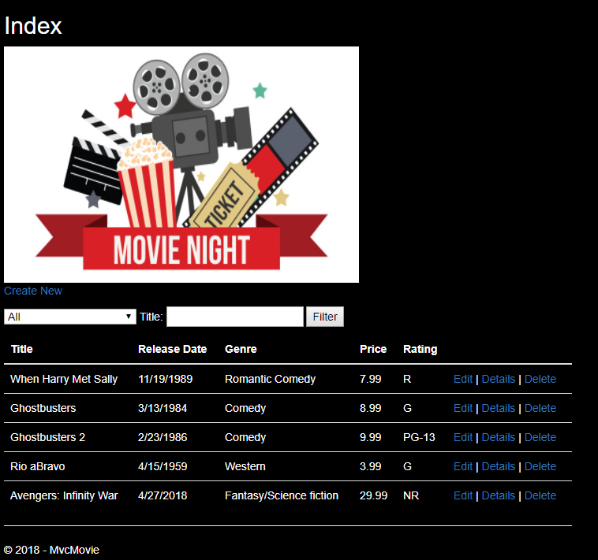**Paste your results of changing the ratings - circle your change:**